****Tarlac State University

**COLLEGE OF COMPUTER STUDIES**

Case Study

in

Integrative Programming Technology 2

Submitted By:

**Beguiras, Reymart V.**

**Cerbito, Paul John D.**

**Corpuz, John Michael**

**Garingo, Harvin P.**

**Reyes, Jose Karlos L.**

Submitted To:

**Kwinno L. Pineda**

**Table of Contents**

1. Definition………………………………………………………………………………………………………………………………. 3
2. Cloning the Remote Repository files to Local repository……………………………………………………………………. 4

B.1 Uploading the files on Github……………………………………………………………………………………………… 4

B.2 Solutions/Implementation……………………………………………………………………………………………….. 4

B.3 Explanation……………………………………………………………………………………………………………………….. 4

1. Minor Changes…………………………………………………………….……………………………………………………………………. 5

B.1 Minor changes on the main branch files……………………………………………………..…………………… 5

B.2 Solutions/Implementation……………………………………………………………………………………………….. 5

B.3 Explanation……………………………………………………………………………………………………………………….. 5

1. Website Portfolio Template………………………………………………………………………………………………………………. 6

B.1 Developing Template………...……………………………………………………………………………………………… 6

B.2 Solutions/Implementation……………………………………………………………………………………………….. 6

B.3 Explanation……………………………………………………………………………………………………………………….. 6

1. Raven Portfolio…………………………………………………………….……………………………………………………………………. 7

B.1 Problem……………………………..……………………………………………………………………………………………… 7

B.2 Solutions/Implementation……………………………………………………………………………………………….. 7

B.3 Explanation……………………………………………………………………………………………………………………….. 7

1. Contributors Portfolio………………………………………………….……………………………………………………………………. 8

B.1 Problem……………………………..……………………………………………………………………………………………… 8

B.2 Solutions/Implementation……………………………………………………………………………………………….. 8

B.3 Explanation……………………………………………………………………………………………………………………….. 8

1. Sample Website…………………………………………………………..……………………………………………………………………. 9

B.1 Problem……………………………..……………………………………………………………………………………………… 9

B.2 Solutions/Implementation……………………………………………………………………………………………….. 9

B.3 Results……...……………………………………………………………………………………………………………………….. 9

1. Summary……………………………………………………………………..………………………………………………………………….. 10

B.1 Git logs………………………………..……………………………………………………………………………………………. 10

B.2 Network Graph & Commits…………………………………………………………………………………………….. 10

B.3 Contributors & Pulse………………………………………………………………………………………………..……… 10

# Definition

* **Git Merge -** Combines sequences of commits into one unified history of commits.It was used to integrate the changes in the file.
* **Issue -** Keep track of tasks, enhancements, and bugs for your projects. It was used to notify the contributor about issues or bugs in a file.
* **Milestone -** track issues and merge requests created to achieve a broader goal in a certain period.It was used to track the progress of our issue in our repository.
* **Branch -** A pointer to a snapshot of your changes.It was used for all contributors in our repository for the Portfolio website.
* **Git clone** - Making a copy from github to local repo. It was used for cloning our existing files in github to local repository.
* **Git Push -** Uploading local repository content to a remote repository. It was used to update our files on the github from the local repository.

**Contributors:**

Beguiras, Reymart V. (Git bash, Github, Front-end, Documentation)

Cerbito, Paul John D. (Github)

Corpuz, John Michael (Github)

Garingo, Harvin P. (Github)

Reyes, Jose Karlos L. (Github)

**Github Repository link:**

https://github.com/RavenDanielle/IPT2-Case-Study.git

# Cloning the Remote Repository files to Local repository (Git and GitHub Workflow)

## Uploading the files on Github

To have a main branch in Github, the previous Lab Quiz 2 files on our website was uploaded on Remote repository.

* Local repository

* Remote repository

Aayusin mamaya

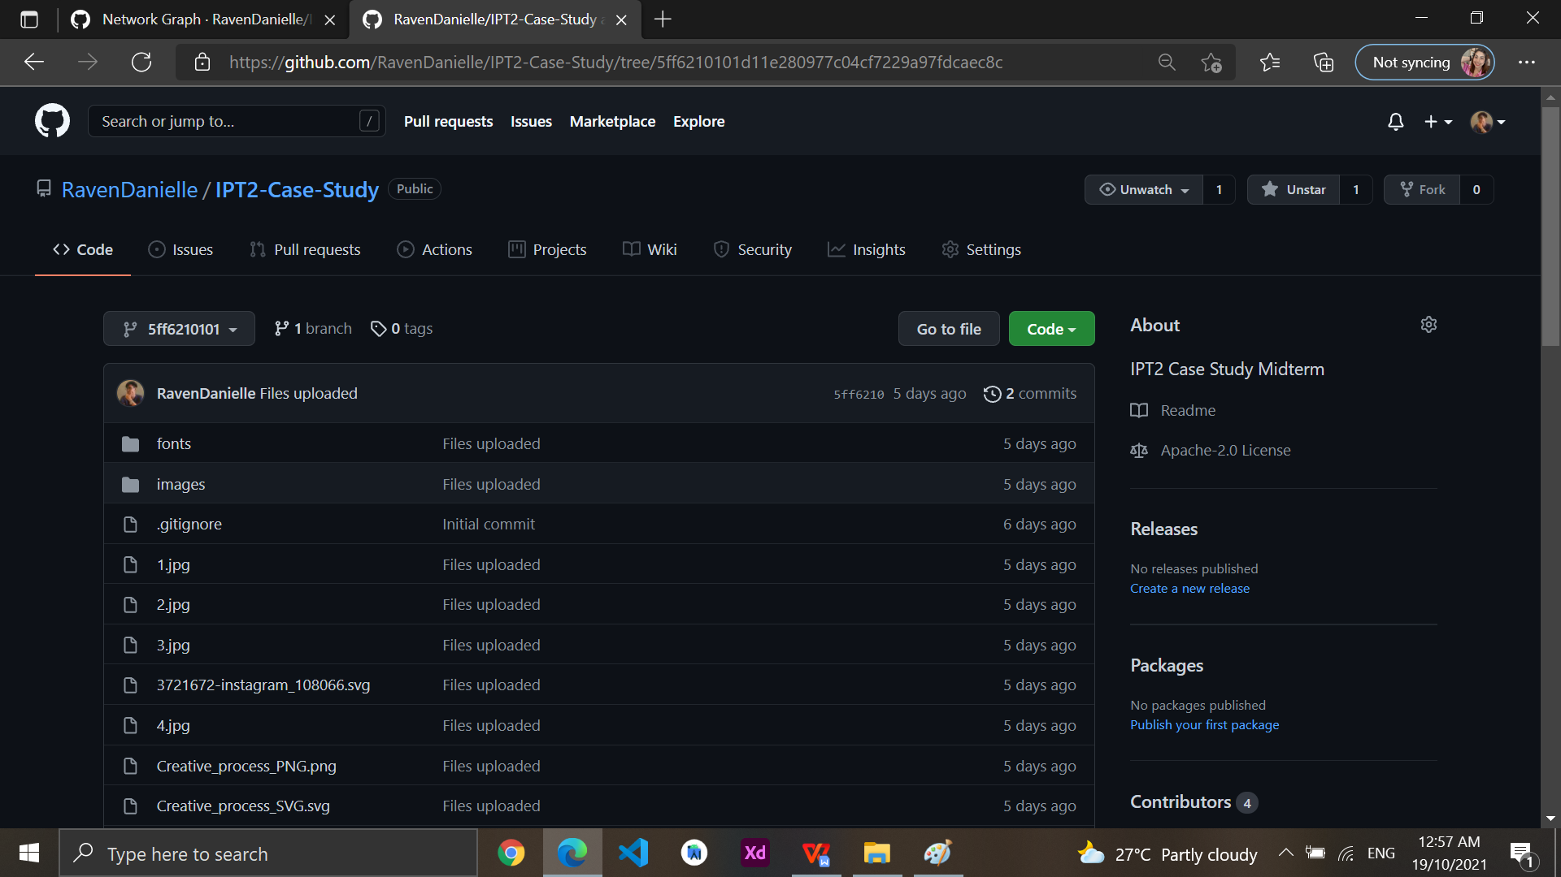

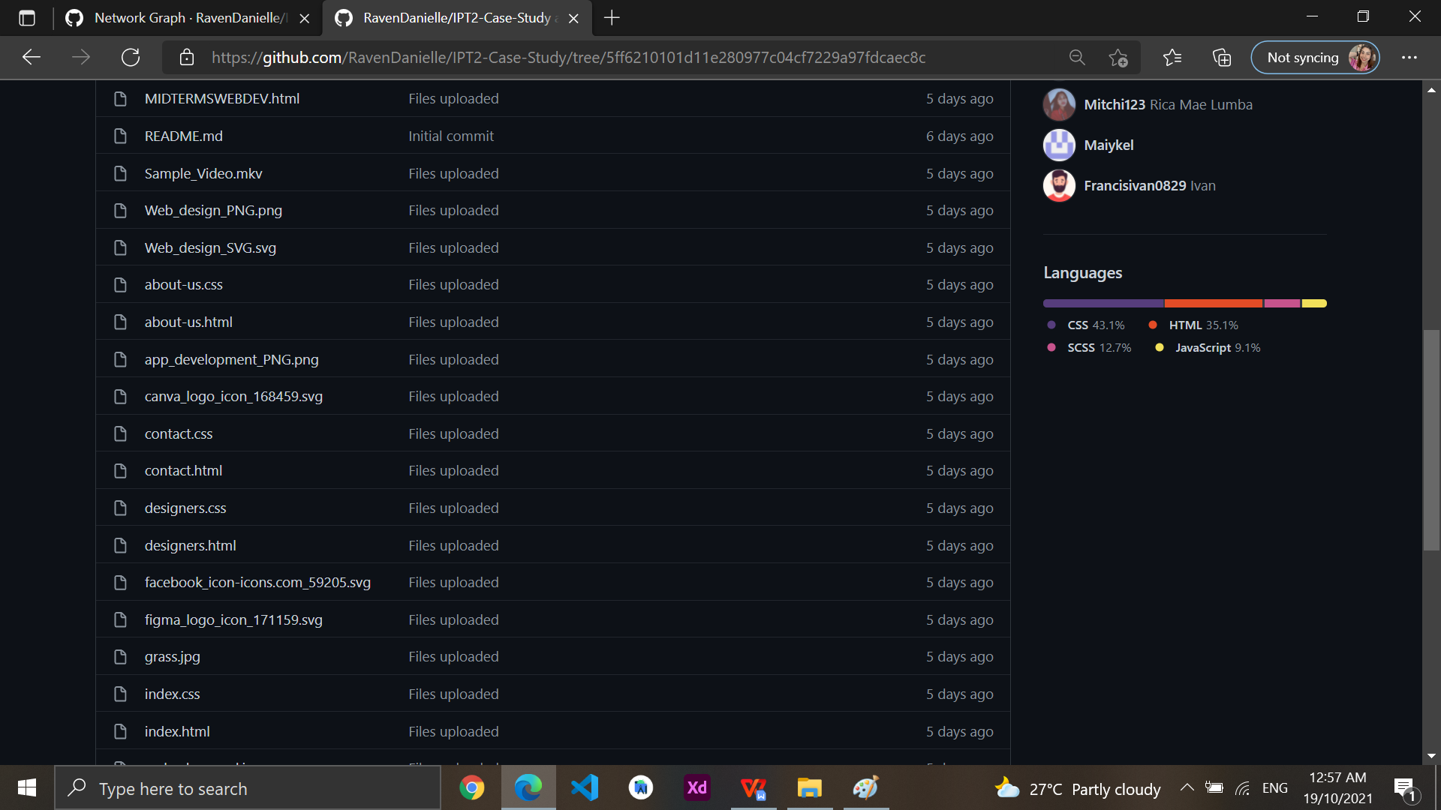

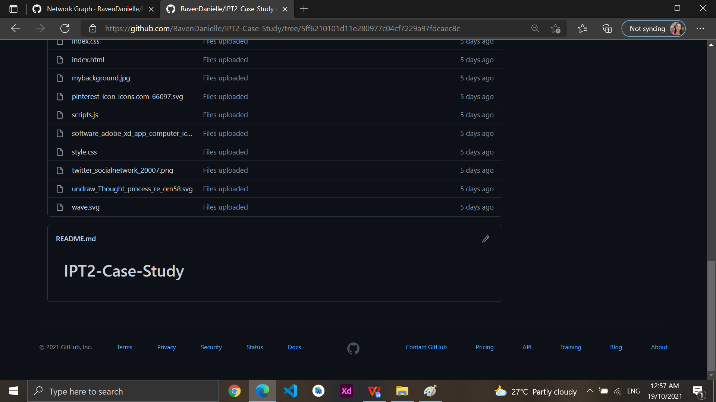

## Solutions/Implementation

We used the command **git clone** https://github.com/beguiras262/IPT2-Case-Study.git to copy the files and make it as a HEAD:main branch.

## Explanation

We used a git clone for Making a copy from GitHub to the local repo. It was used for cloning our existing files in GitHub remote repository to the local repository.

# Minor Changes (Git and GitHub Workflow)

## C.1 Minor Changes on the main branch Files

The image link of Beguiras is not properly working and we need a few changes too in the paragraph on the About us tab. So we made changes to fix the issue on it.

## C.2 Solutions/Implementation

We created a branch for making an update for his new Profile picture

After that, we merged **beguiras-updating-dp** branch to **main** branch.

After merging it, we deleted the branch.

This is now the new updated code for Beguiras Display Picture.

In the Front Page, We made a little changes in the information and merged it along the Main branch.

After all the changes, we pushed it to the remote repository to update all the files.

## C.2 Explanation

We branched all the changes that need to be revised to review the file before merging it to the main branch. We used the git branch to make a copy of the **beguiras-updating-dp** and merge it in the main branch. After we merged it we deleted the branch using git branch -d beguiras-updating-dp.

# Website Resume Template (Git and GitHub Workflow)

## D.1 Developing Template

After all of the minor changes in all files, We started to upload our finished Front Page HTML.

## D.2 Solution/Implementation

The first template was finished and I used Git push to push my file into the remote repository. After that, I made an upload on FrontPage Html for the other contributors for them to edit their information about their educational background.

All the files we programmed were uploaded to the remote repository.

## D.3 Explanation

We finished first the template of our Web portfolio before pushing it to the main branch in our remote repository. We used the command **Git push origin HEAD:main** to update the main branch.

# Beguiras Resume (Git and GitHub Workflow)

## E.1 Problem

Beguiras Resume doesn’t have still a display picture for his Resume. So we made an Issue to revise the issue on the file.

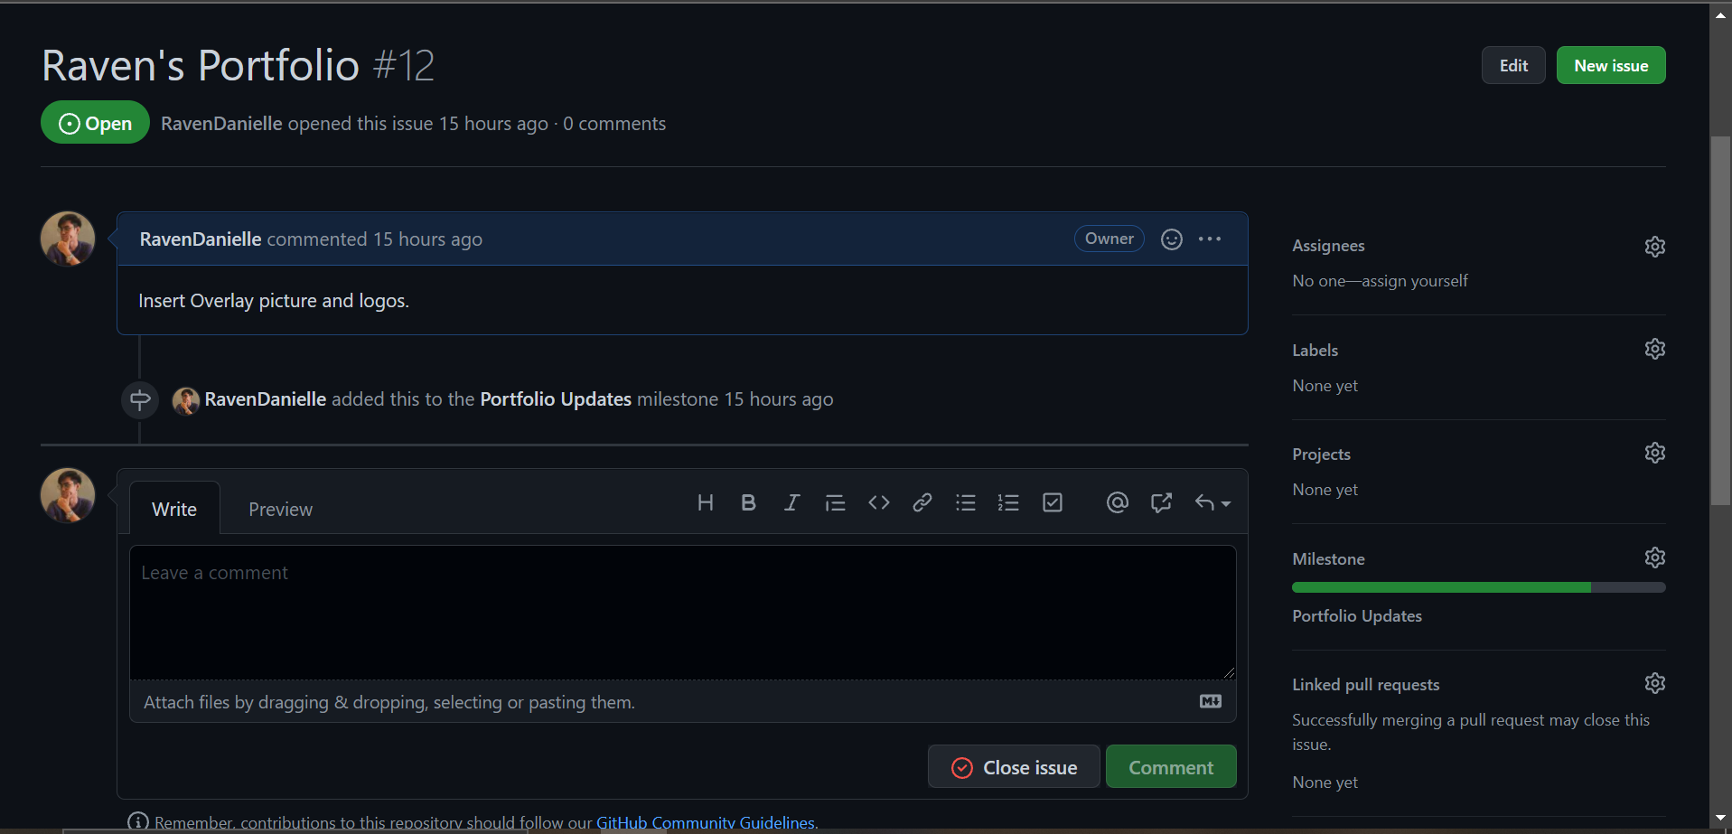

## E.2 Solution/Implementation

Added a new branch called “raven-branch” to update the Web portfolio of Raven then after that, we merged it in to the main repo and pushed it to the main branch in remote repository .

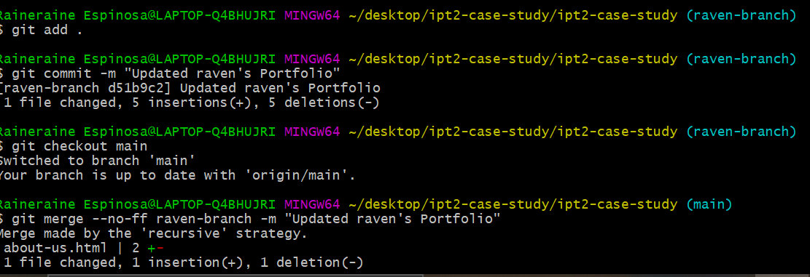

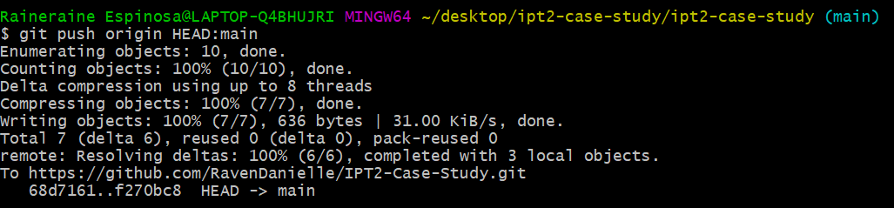

## E.3 Explanation

Now the Web portfolio of Beguiras is updated, the display picture for his resume is now inserted. We used **git branch** and named it as **beguiras-updating-dp** to review the file first before merging it to the main branch and uploading it to the remote repository. The issue is now closed. This is the final output.

# Contributors Portfolio (Git and GitHub Workflow)

## F.1 Problem

After the Template is created, the template files are uploaded to a remote repository so that contributors can edit their HTML files. The content of the template is image and they are Bio only. Their Educational background is not here yet and that is what they need to edit. We create a new issue to record the progress of their works and record it in milestones.

## F.2 Solution/Implementation

Contributor’s (Cerbito, Corpuz, Garingo, Reyes) HTML files are already finished. They edited their HTML file through Github if there is any issues or errors. After merging the files they edited, we closed the issues and automatically recorded in our milestones. We used the command **git pull <link>** to update our local repository after all those changes.

**Cerbito**

* **Corpuz**

* A screenshot of a computer

  Description automatically generated**Reyes**

## F.2 Explanation

After updating their HTML files via GITHUB

# Sample Website (Git and GitHub Workflow)

## G.1 Description

In the previous sample website, the sample website the information of the people who have made changes, which is updating the Front Page.

## G.2 Solution/Implementation

We finished the updating the **Front Page** first before we push it to the main branch. After that we pushed the files by using **git push origin HEAD:main** so that the main branch will be updated.

## G.3 Result

The Front page now is way better than before. It’s better to read all the information about our team. This is our final output for our Front page.

# Summary (Git and GitHub Workflow)

## H.1 Git logs

This is the git log histories we’ve made for our Website

## H.2 Network Graph & Commits (Github)

## H.3 Contributors & Pulse